

National Textile University
Department of Computer Science
Subject: Mobile Application Development

Submitted to: Sir Rehan

Submitted by: Ayema

Reg. number: 23-NTU-CS-1142

Lab Evaluation

Semester:6th

Code:
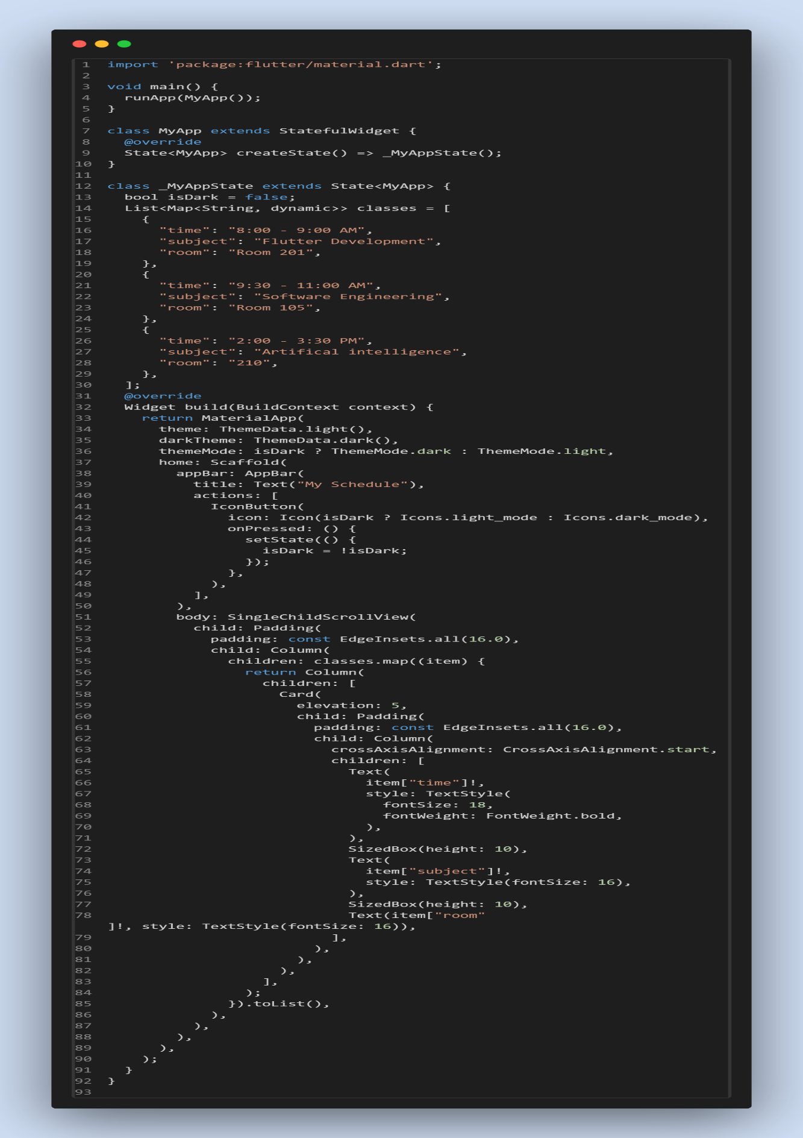5

Light mode:
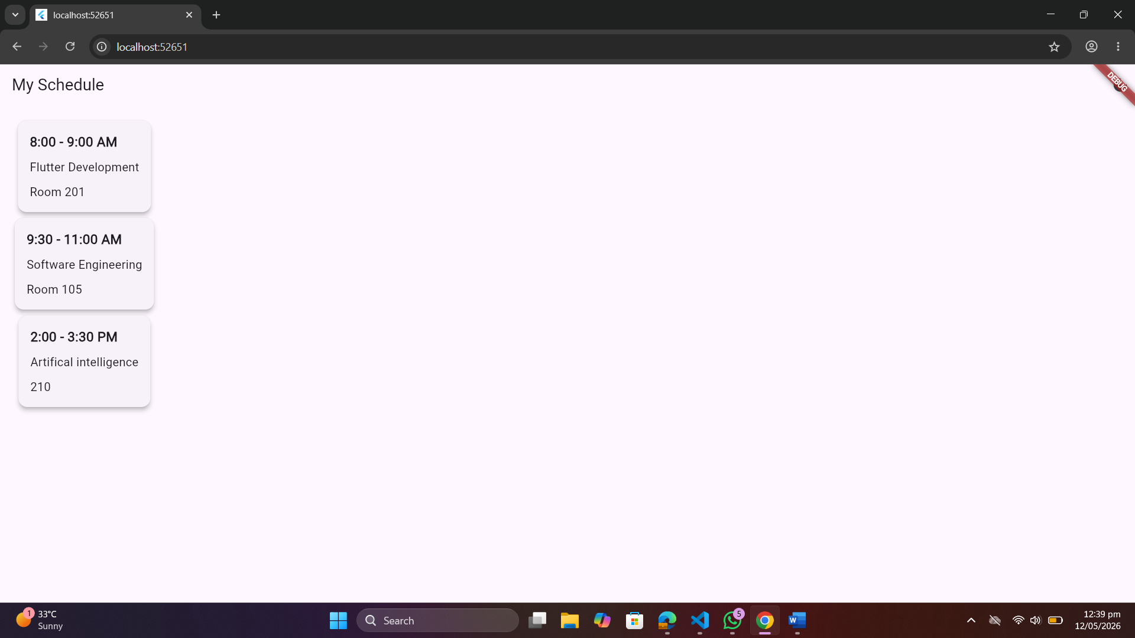
Dark Mode:
